# Setup guide

MongoDB should be installed, once it is open the command line or terminal and move to the bin folder in MongoDB’s folder, its in my program files

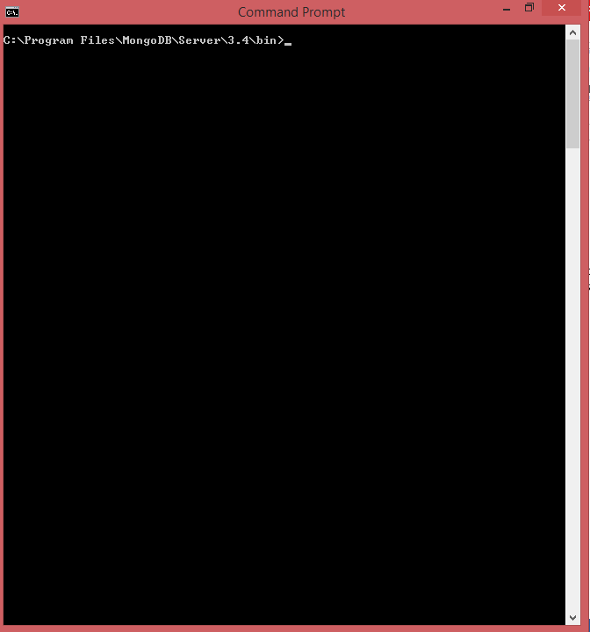

Type the command mongod –dbpath “C:/Path/to/Data/folder/in/Project” –port 27017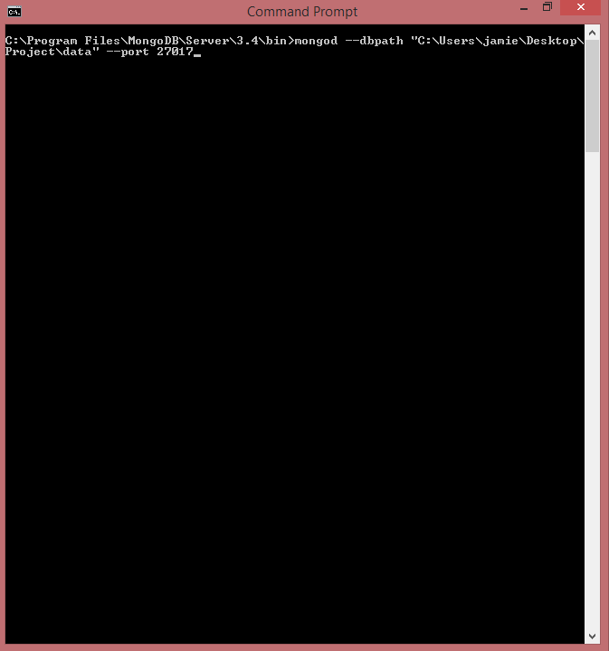

You should see something like this

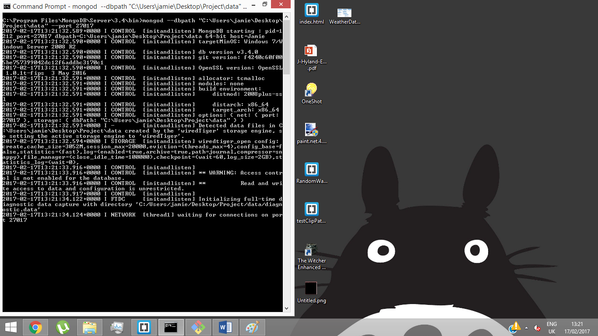

Then open up the project folder and open up the cmd or terminal there, I’m using git bash but any of them work.

To download the necessary modules for the project make sure to run the command npm install if they are not already installed (They should be because Im including the folder but just incase)

To run the app simply type node app.js into the command line or terminal

You will see a log to the console indicating the server is listening on port 8081

